|  |  |
| --- | --- |
|  |  |

|  |  |
| --- | --- |
| **System Analysis and Design –2nd June 2024**  **--Who builds entire System (System point of view) -Bigger picture, how do scale a system**  1)Example:  2) Build Chatbot of your own -tech stak, system design  3) Build youtube  4)Linked in | Think about broader lever –do some distributions, handle multiple requests, faster (CDN, cache)  Main logic- More you disintegrate the system –u can separated each modulue and make it scalability |
|  |  |
|  | 1. CDN provides data w.r.t to audio and video (video rendering)   Content Delivery network -stores static thing and able to access fast  CDN An example: gives header and footer images static images and shows as per region-(based on request region)- It is focused on transfer and latency  Azure AI studio , development kit –   1. Cache provides data wr.t to small data size -metadata info 2. Queueing system 3. Rate Limiting   -Dialog flow  - AI enabled chatbot  **Rate limiting** applies to the number of calls a user can make to an API within a set time frame. This is used to help control the load that's put on the system. Rate limiting helps prevent a user from exhausting the system's resources. Without rate limiting, it's easier for a malicious party to overwhelm the system.  A content delivery network (CDN) is a geographically distributed group of servers that caches content close to end users. A CDN allows for the quick transfer of assets needed for loading Internet content, including HTML pages, JavaScript files, stylesheets, images, and videos.  A primary reason for using a CDN is to significantly boost your website's speed and performance. CDNs have servers distributed across various geographical locations. |
|  | Stateful is limited to particular server  So I fuser sesion1 logics, same users data exists like login credentials, he will able to access only session.  So we go for stateless server..  , so we move session data to shared storage  Ex: 🡪User session1 is limited to User session 2 |
|  | Design Rate limiter –  How to overcome Rate limiter   1. Token Based system(algorithm) to build the rate limiter 2. Queue system |
|  | **Consistency and Availabiltiy, PArtition:**  **CAP Theorem:** |
|  | **Possible Solutions:**   1. **UUID -128 bit or** 2. **Use datatime stamp number, Machine id + daacenter ID** |
|  | **Solution:**  **Hashcode ,**  **Load balancer, Webserver, cache , CDN ,Database** |
|  | **First thing: First discuss what is scope of functionality, it will have multiple functionalities**  **What is the average number of requests it handles..**  **Ask basic multiple questions, you want to design the system –But don’t ask too many question, you –you need to also show your caliber in solution**  Solution:  Create a basic diagram and explain  1)Video which is constant can be put in CDN  2) Other info like video details, metadata, Number of videos , person name, , video ID etc are to be stored in API servers  Note: static data ito access fast is sored in CDN |
|  | 1. Meta whatsapp API, 2. Send a bulk email 3. Bulk message services and we send it via them 4. Step1: Collect Contact Info --Capture contact details, phone number, email ids, 5. Step 2: |
| Makign your own chatbot  Make your own Instagaram,  Make | **Why is rate limiting used?**   * Avoid resource starvation due to a Denial of Service (DoS) attack. * Ensure that servers are not overburdened. Using rate restriction per user * ensures fair and reasonable use without harming other users. * Control the flow of information, for example, prevent a single worker from * accumulating a backlog of unprocessed items while other workers are idle. |

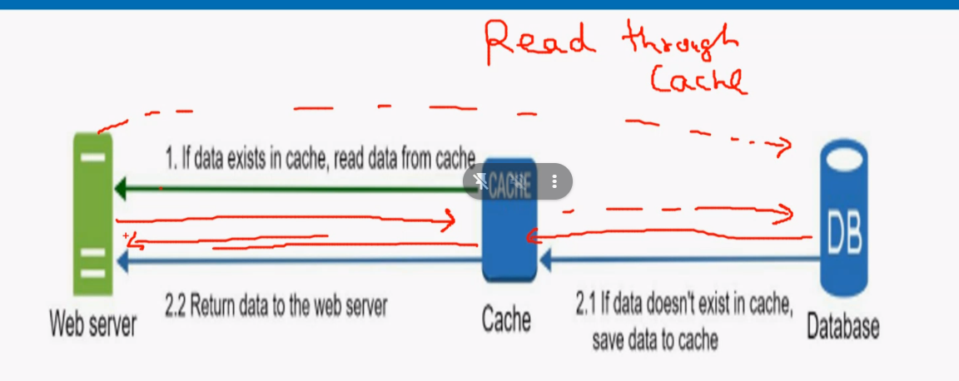

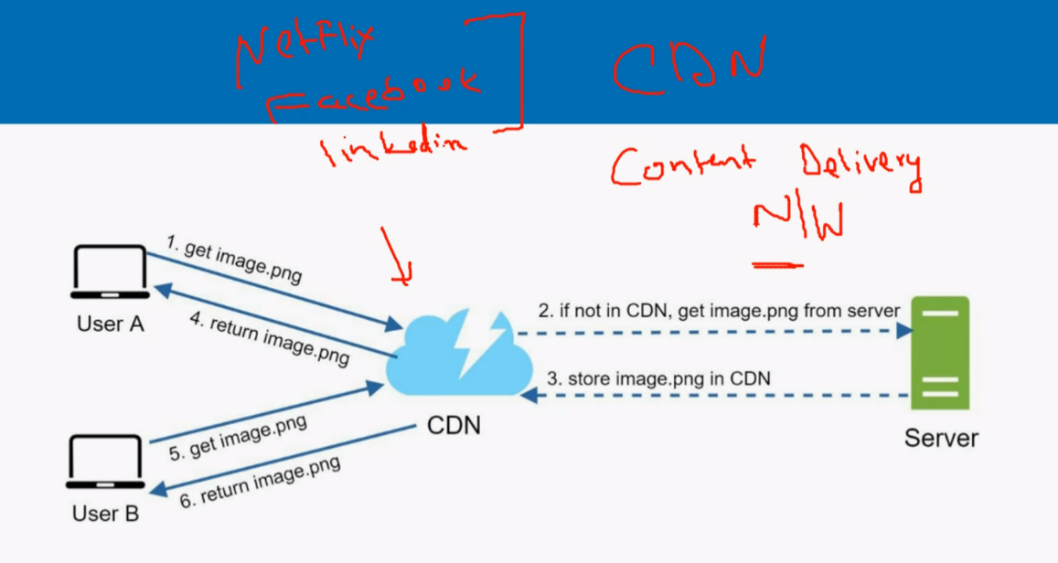

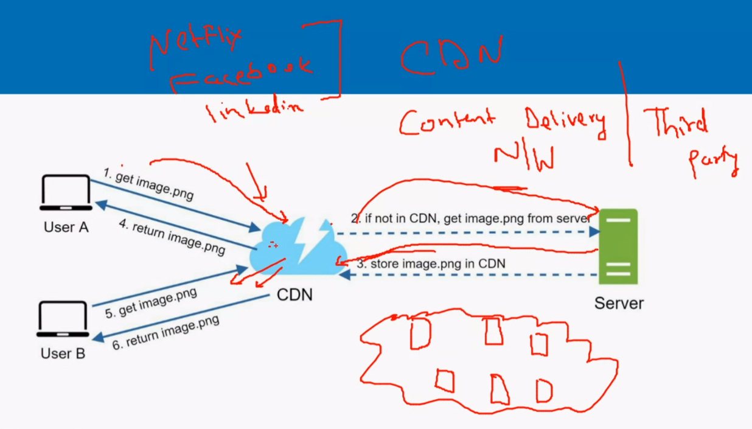

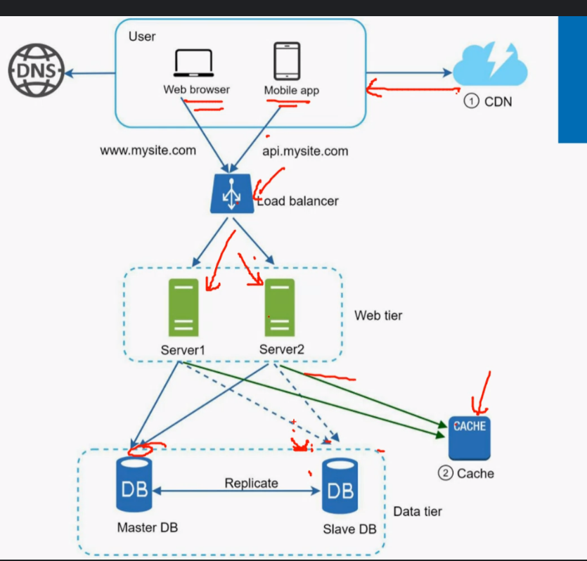

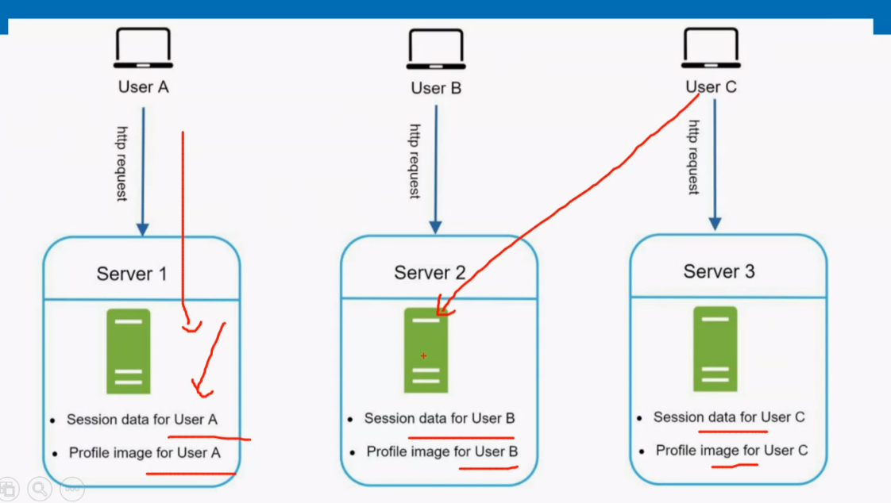

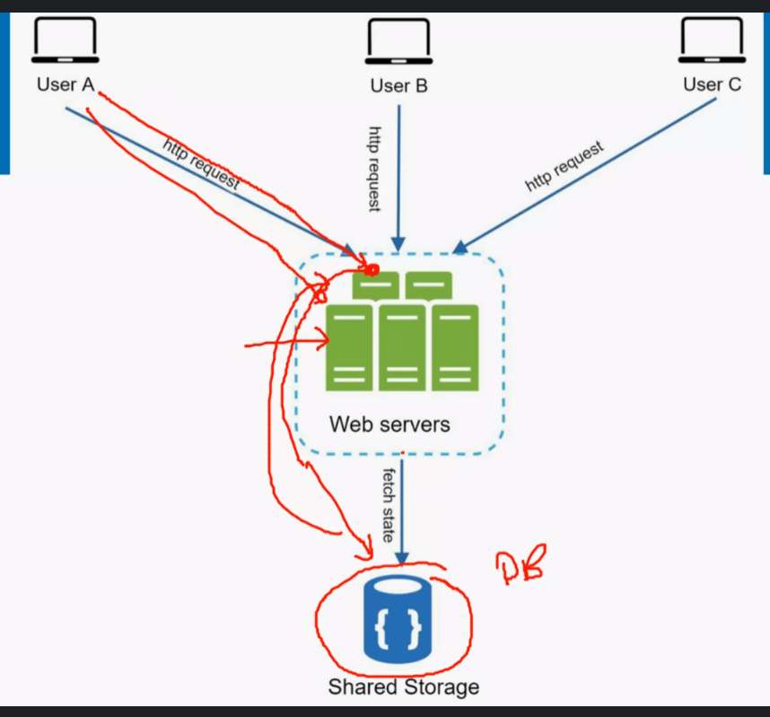

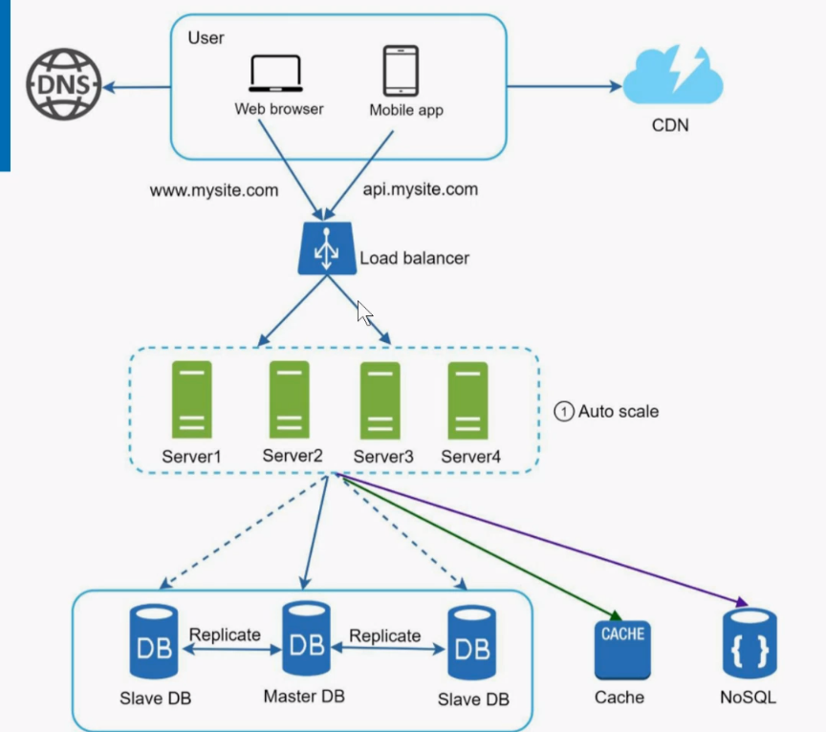

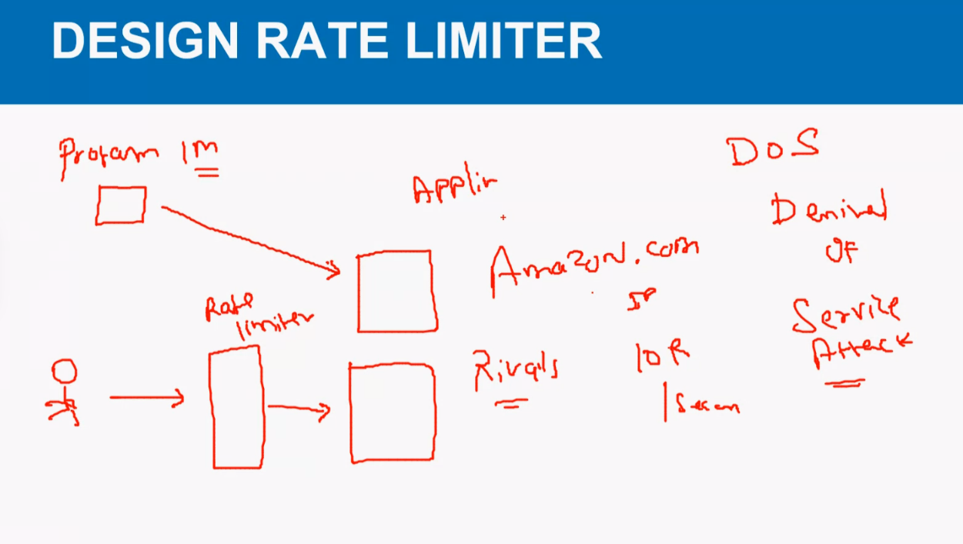

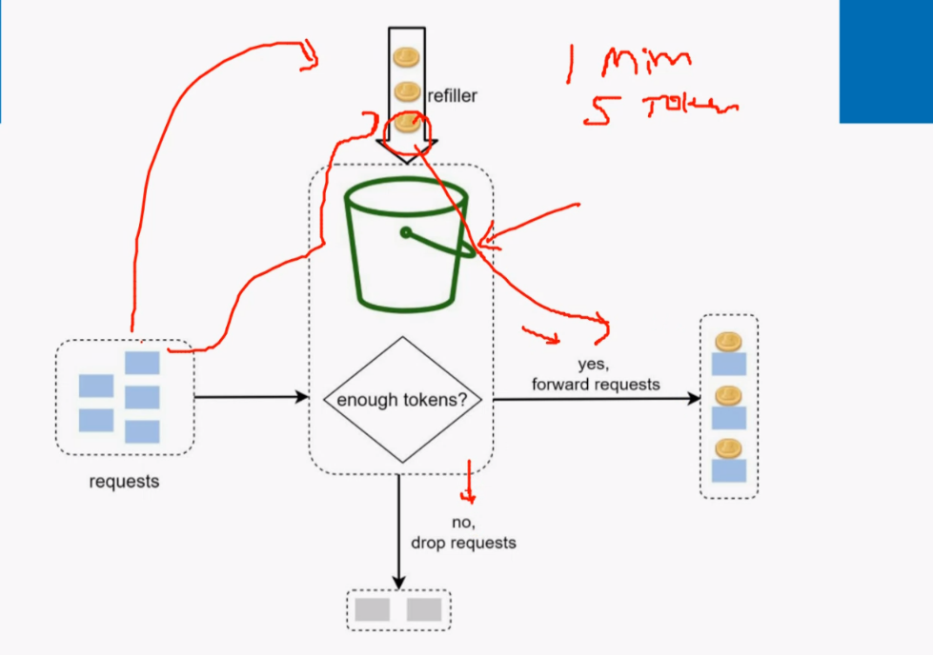

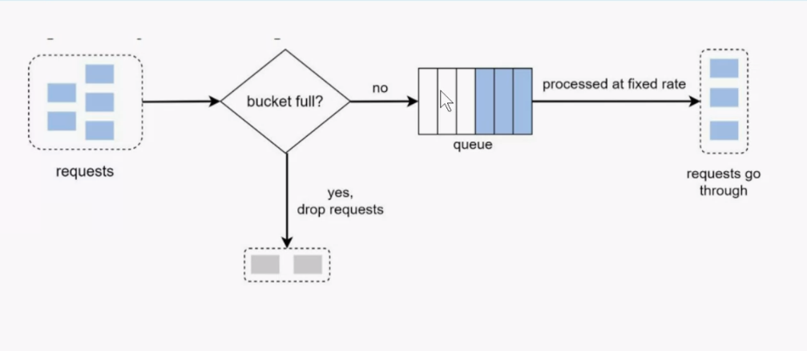

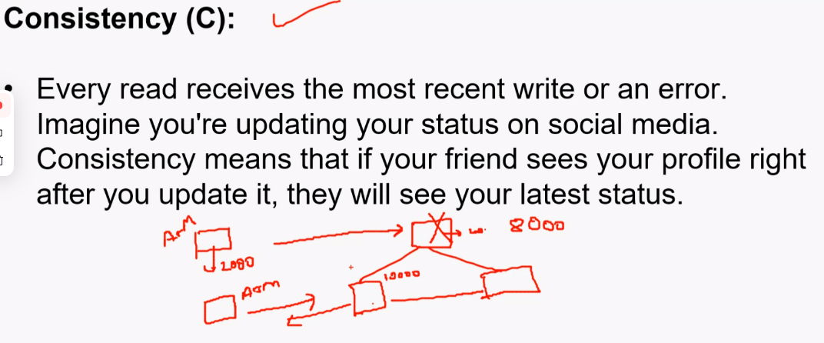

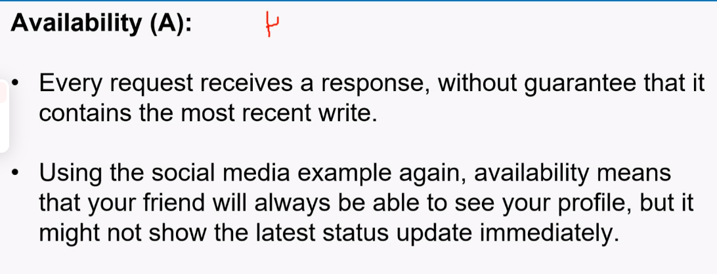

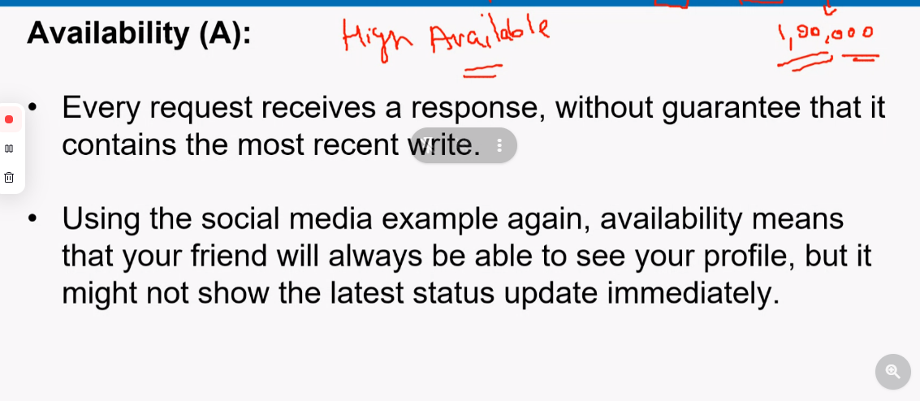

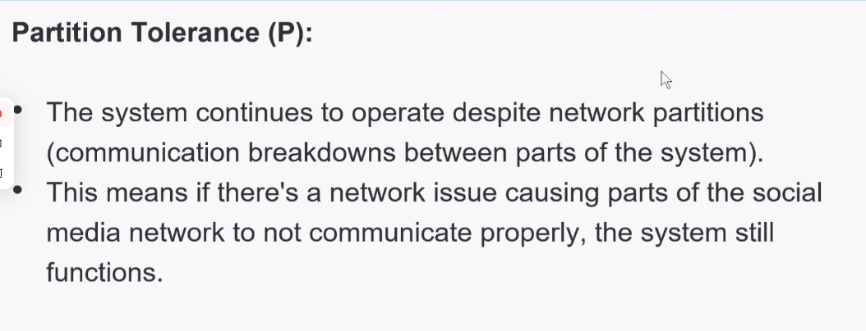

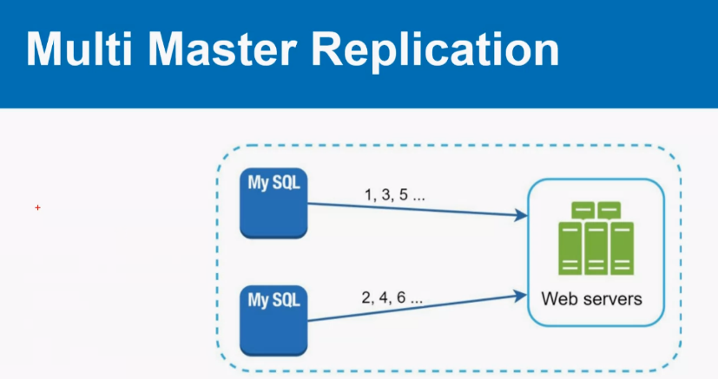

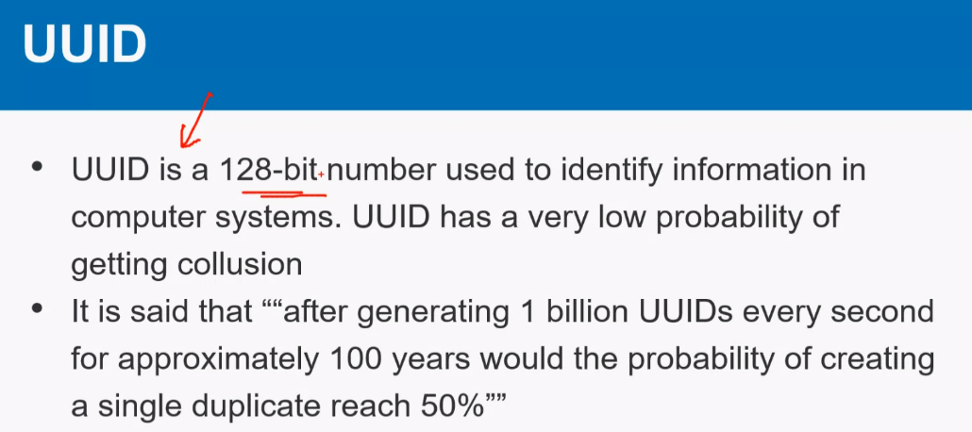

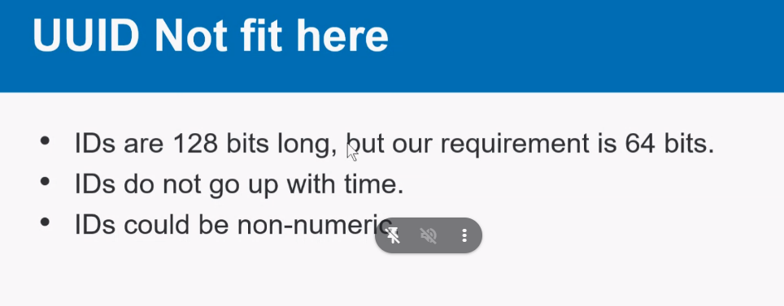

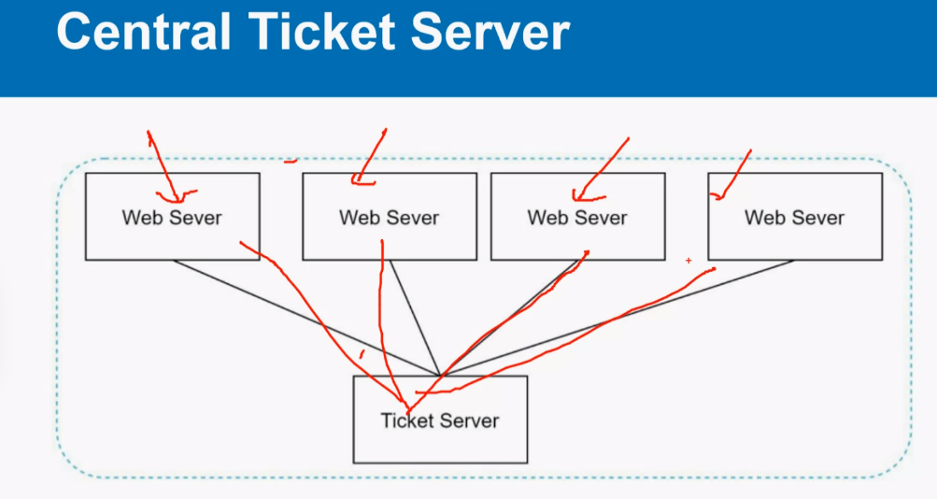

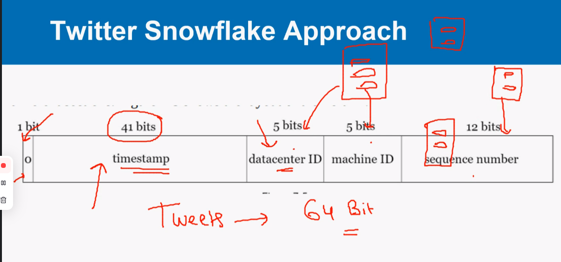

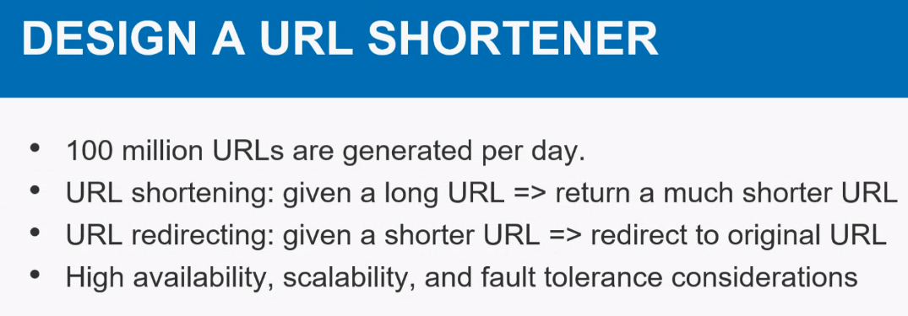

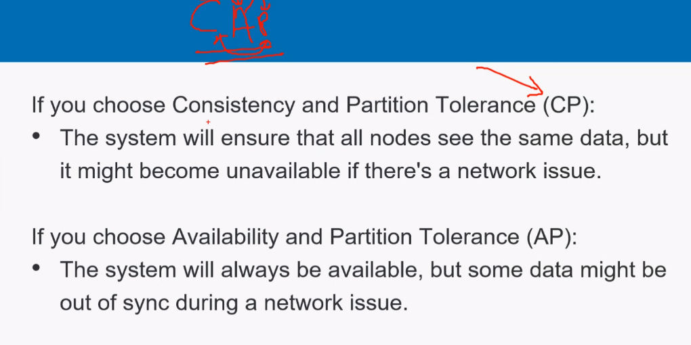

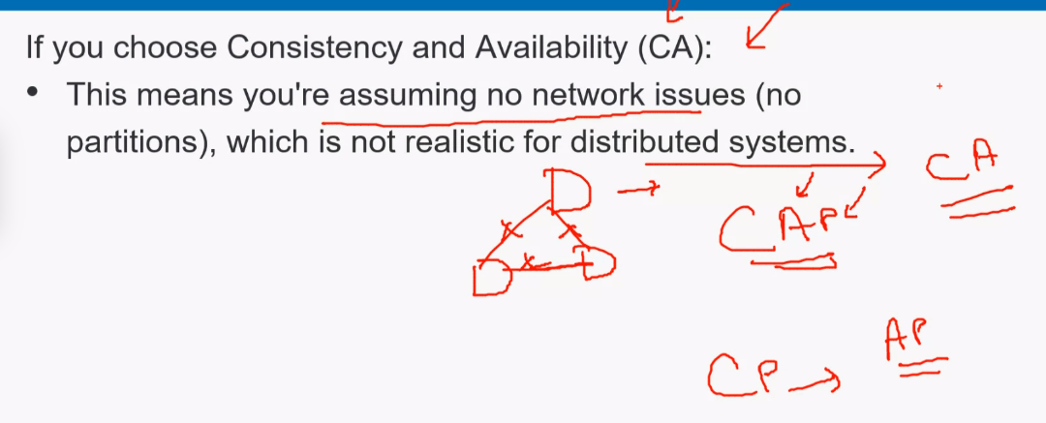

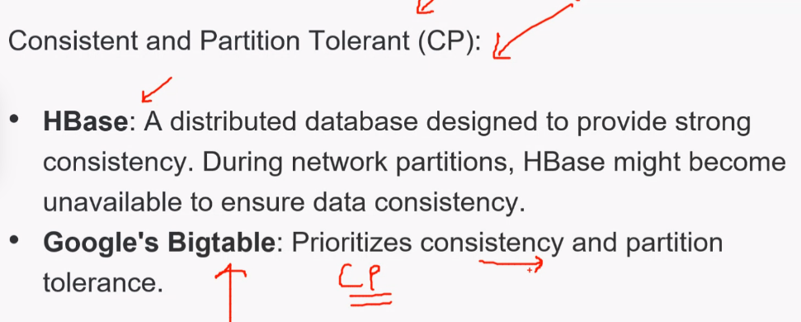

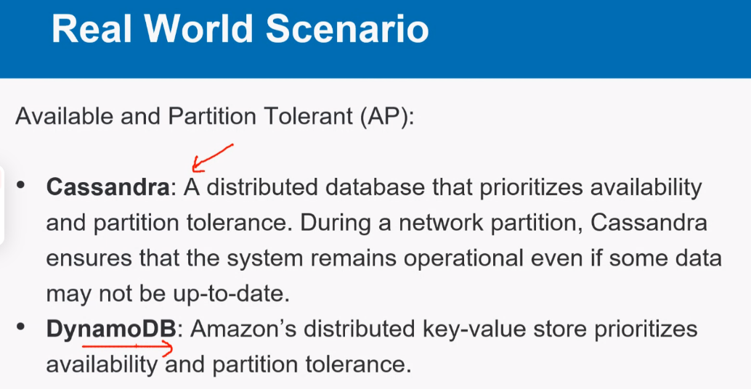

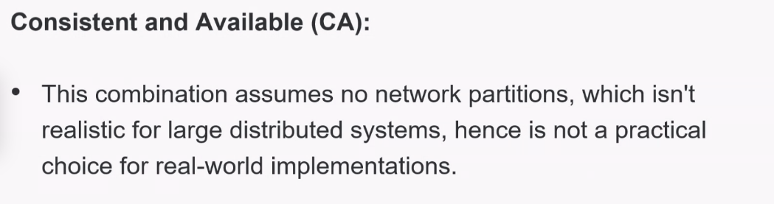

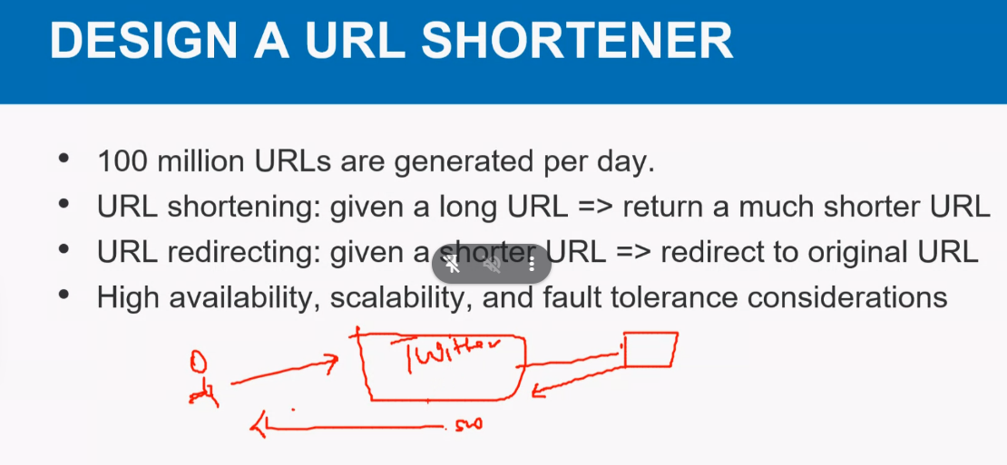

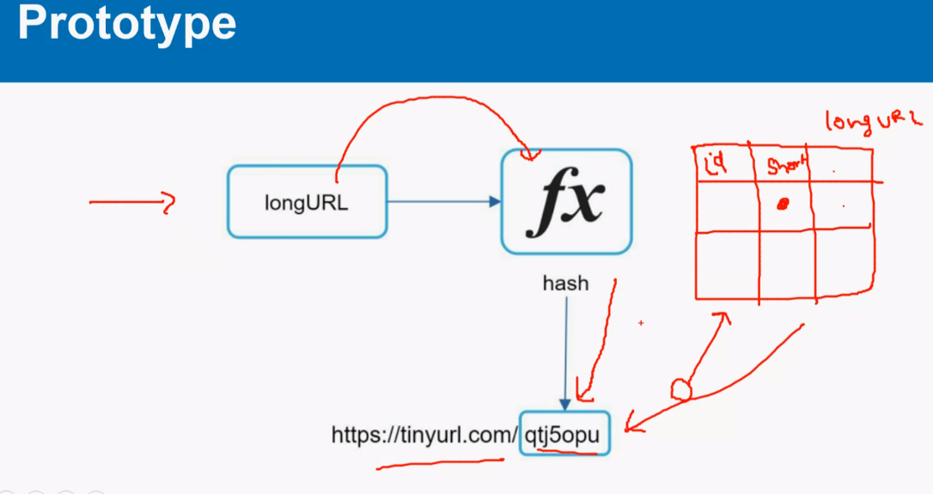

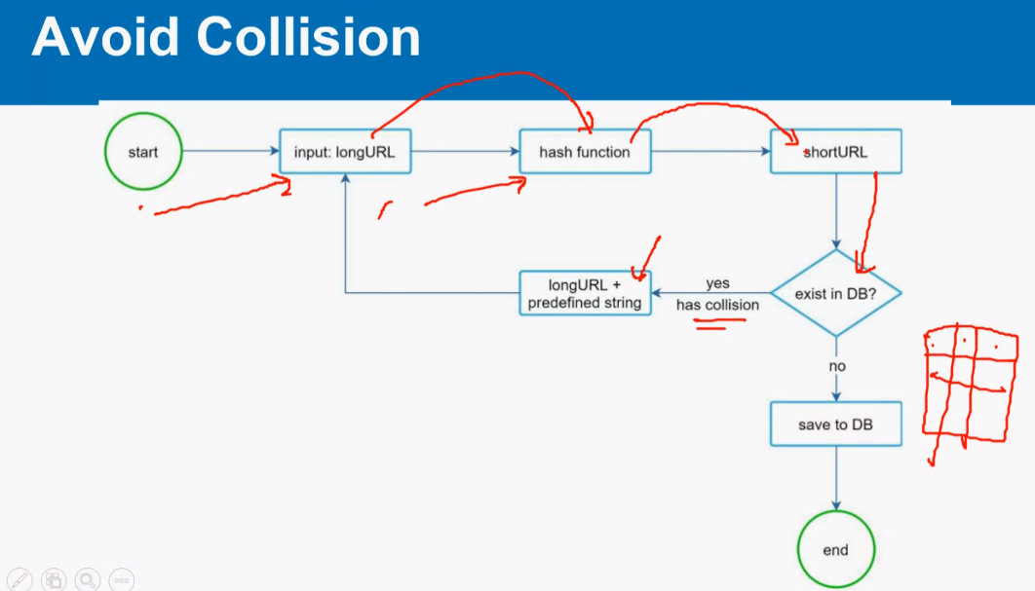

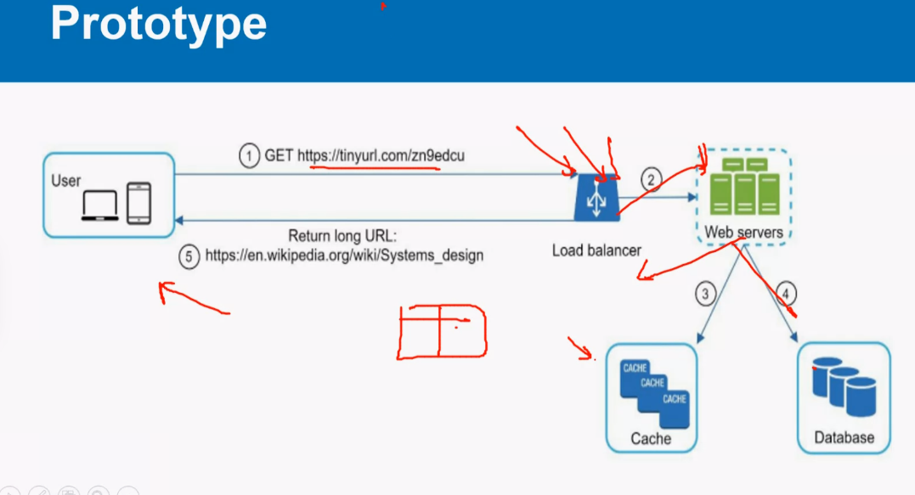

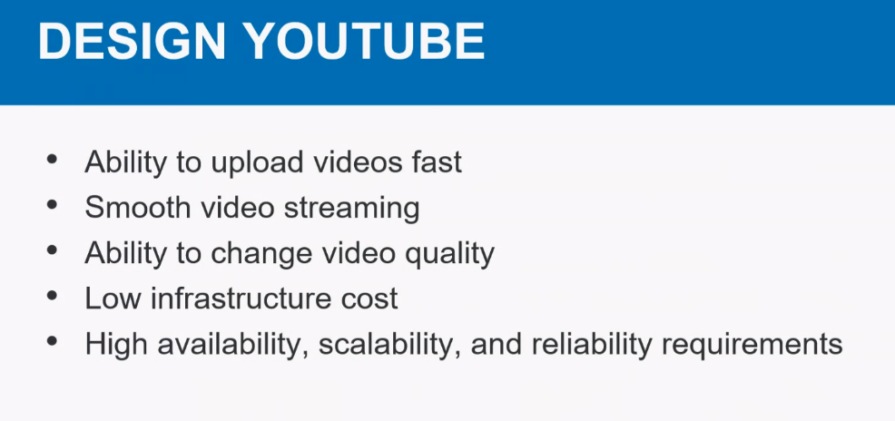

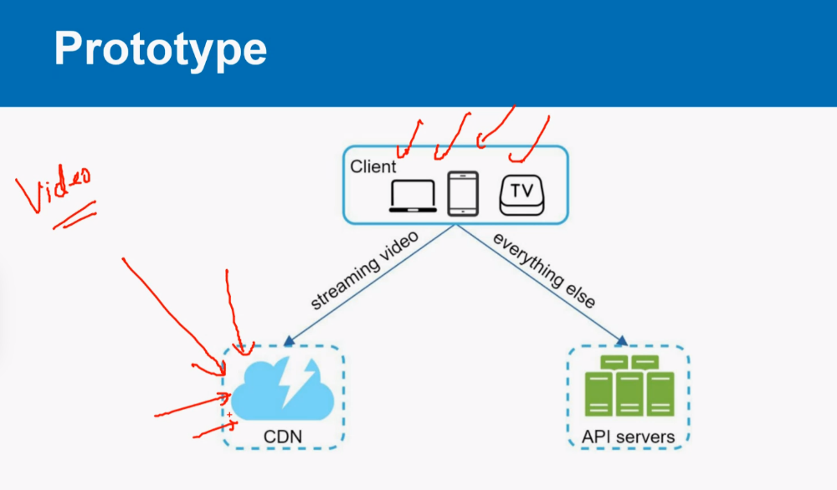

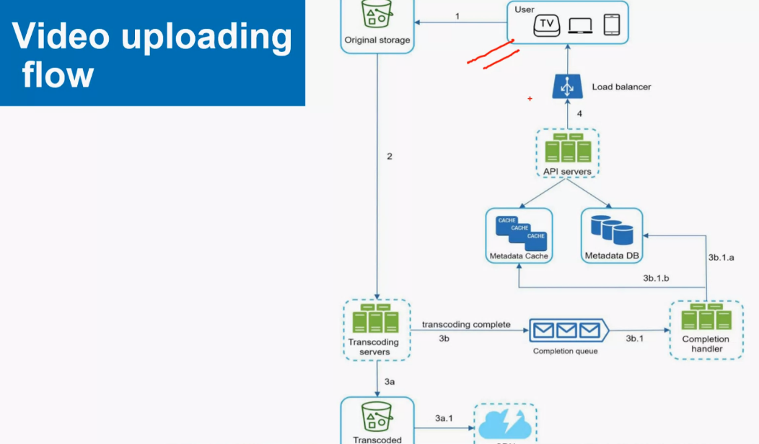

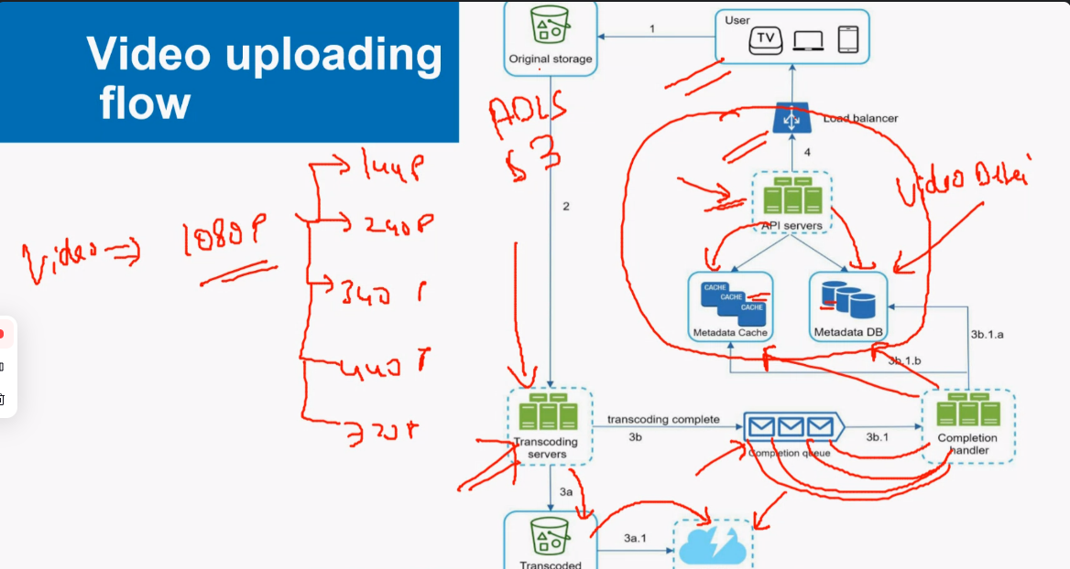

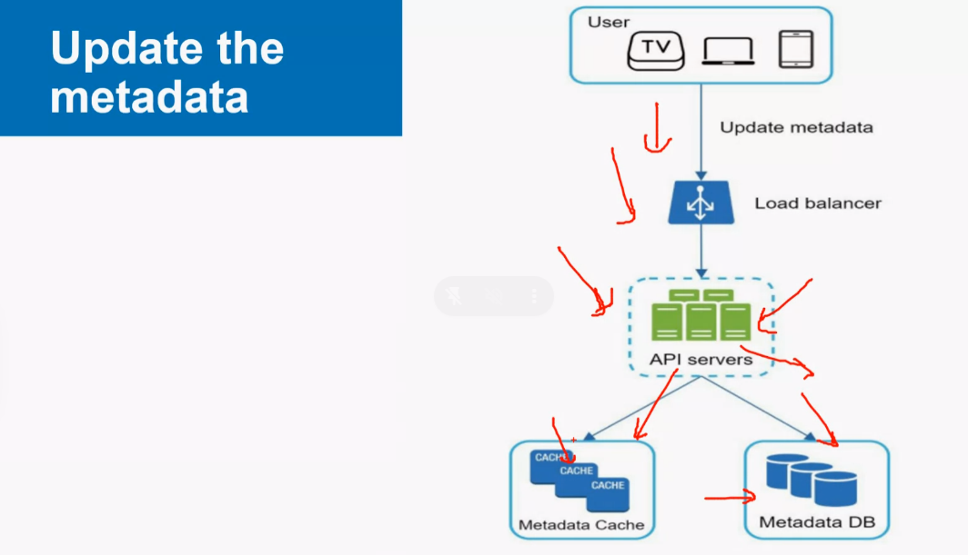

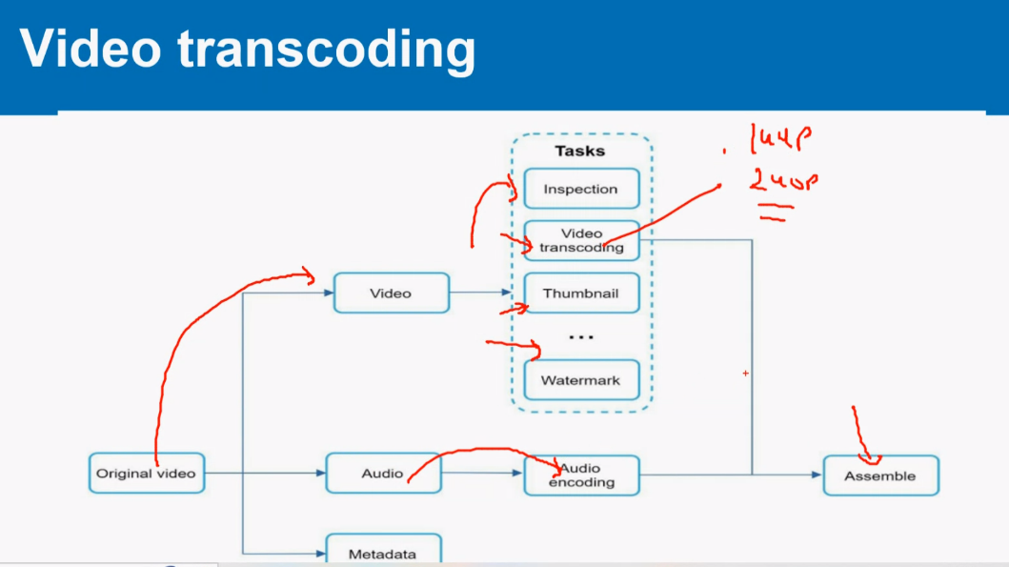

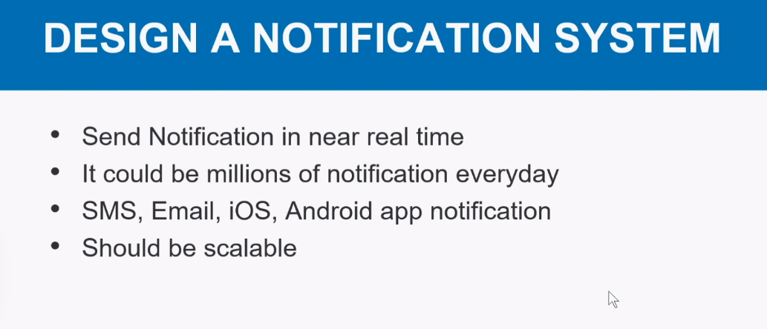

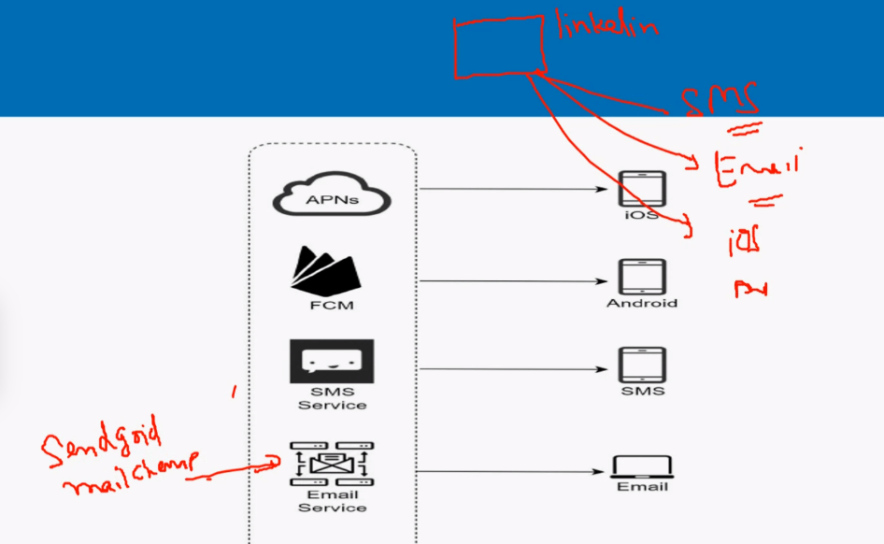

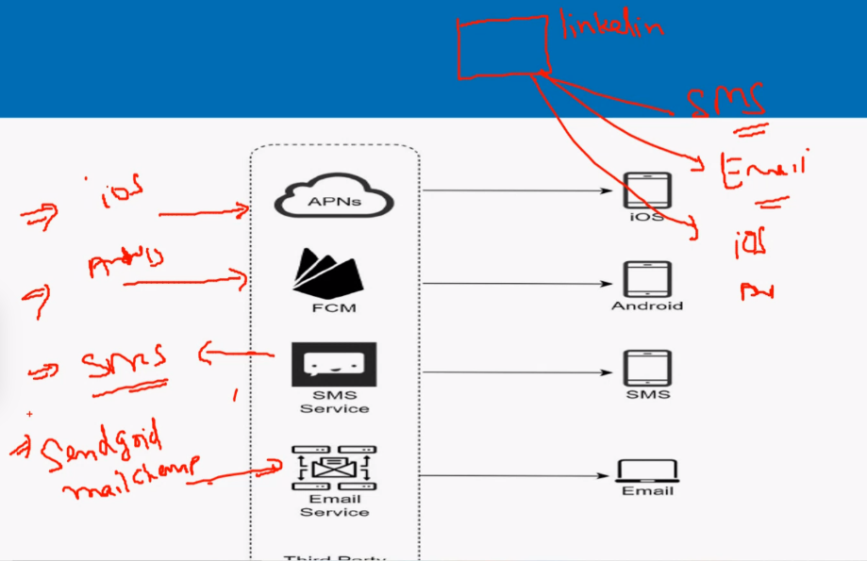

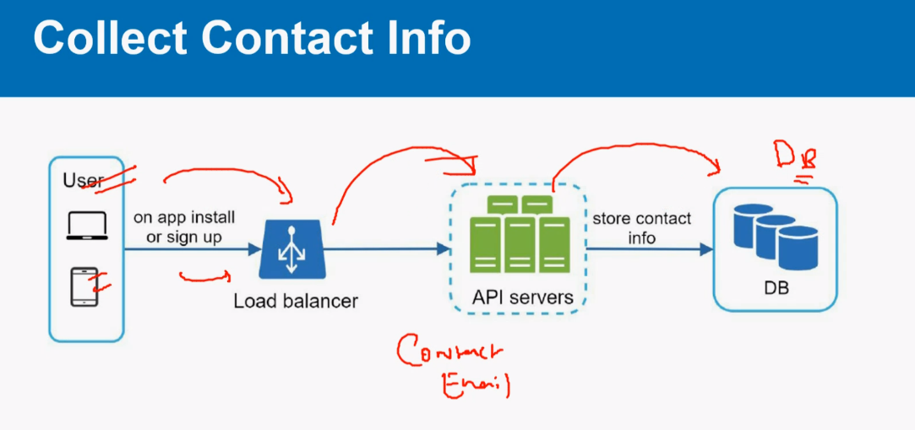

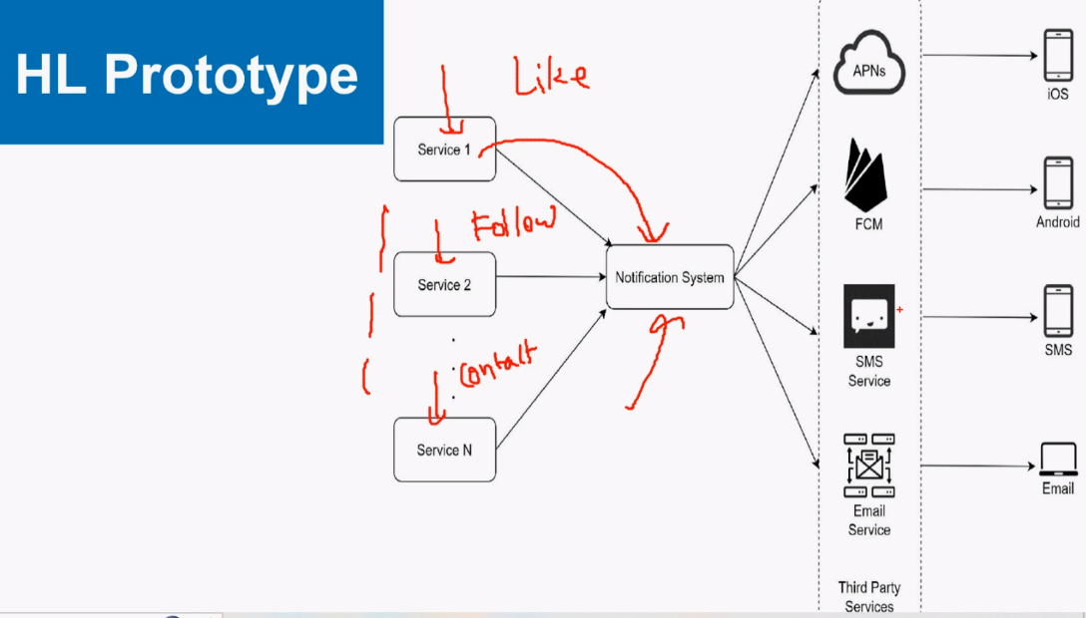

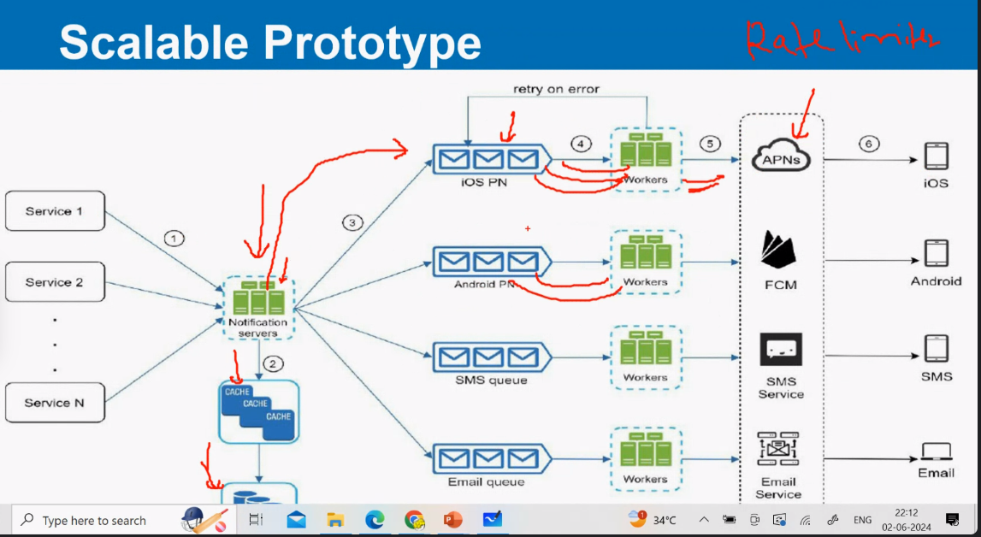

|  |  |
| --- | --- |
| **System Analysis and Design –2nd June 2024**  **--Who builds entire System (System point of view) -Bigger picture, how do scale a system**  1)Example:  2) Build Chatbot of your own -tech stak, system design  3) Build youtube  4)Linked in | Think about broader lever –do some distributions, handle multiple requests, faster (CDN, cache)  Main logic- More you disintegrate the system –u can separated each modulue and make it scalability |
|  |  |
|  | 1. CDN provides data w.r.t to audio and video (video rendering)   Content Delivery network -stores static thing and able to access fast  CDN An example: gives header and footer images static images and shows as per region-(based on request region)- It is focused on transfer and latency  Azure AI studio , development kit –   1. Cache provides data wr.t to small data size -metadata info 2. Queueing system 3. Rate Limiting   -Dialog flow  - AI enabled chatbot  **Rate limiting** applies to the number of calls a user can make to an API within a set time frame. This is used to help control the load that's put on the system. Rate limiting helps prevent a user from exhausting the system's resources. Without rate limiting, it's easier for a malicious party to overwhelm the system.  A content delivery network (CDN) is a geographically distributed group of servers that caches content close to end users. A CDN allows for the quick transfer of assets needed for loading Internet content, including HTML pages, JavaScript files, stylesheets, images, and videos.  A primary reason for using a CDN is to significantly boost your website's speed and performance. CDNs have servers distributed across various geographical locations. |
|  | Stateful is limited to particular server  So I fuser sesion1 logics, same users data exists like login credentials, he will able to access only session.  So we go for stateless server..  , so we move session data to shared storage  Ex: 🡪User session1 is limited to User session 2 |
|  | Design Rate limiter –  How to overcome Rate limiter   1. Token Based system(algorithm) to build the rate limiter 2. Queue system |
|  | **Consistency and Availabiltiy, PArtition:**  **CAP Theorem:** |
|  | **Possible Solutions:**   1. **UUID -128 bit or** 2. **Use datatime stamp number, Machine id + daacenter ID** |
|  | **Solution:**  **Hashcode ,**  **Load balancer, Webserver, cache , CDN ,Database** |
|  | **First thing: First discuss what is scope of functionality, it will have multiple functionalities**  **What is the average number of requests it handles..**  **Ask basic multiple questions, you want to design the system –But don’t ask too many question, you –you need to also show your caliber in solution**  Solution:  Create a basic diagram and explain  1)Video which is constant can be put in CDN  2) Other info like video details, metadata, Number of videos , person name, , video ID etc are to be stored in API servers  Note: static data ito access fast is sored in CDN |
|  | 1. Meta whatsapp API, 2. Send a bulk email 3. Bulk message services and we send it via them 4. Step1: Collect Contact Info --Capture contact details, phone number, email ids, 5. Step 2: |
| Makign your own chatbot  Make your own Instagaram,  Make | **Why is rate limiting used?**   * Avoid resource starvation due to a Denial of Service (DoS) attack. * Ensure that servers are not overburdened. Using rate restriction per user * ensures fair and reasonable use without harming other users. * Control the flow of information, for example, prevent a single worker from * accumulating a backlog of unprocessed items while other workers are idle. |